Smart Assistant For Public Parks Using IBM Watson

**Project Description**

* Creating a smart assistant for public parks using IBM chat bot services.
* Taking the user’s voice input and converting that to text using the speech to text service.
* Taking the user’s text input and converting that to voice using the text to speech service
* Use the cloud ant DB service if we want to store the data.

**Programming Language**

* Python

Skills Required

### Python.

### Watson Assistant AI Service.

### Speech To Text Service.

### Text To Speech Service.

### Node-Red Application.

chat bot

**1.Introduction**

**Chatbot assistant**

Chatbots are one of the most exciting and in-demand topics in tech. ... Within it, you'll learn how to plan, build, test, analyze, and deploy your first chatbot. Leveraging the AI power of Watson Assistant, you will be able to design your own chatbot without the need to write any code.

## **1.1 Overview**

With IBM Watson Assistant, you can build conversational interfaces into any application, device, or channel. Most virtual assistants try to mimic human interactions, but Watson Assistant is more. Watson Assistant knows when to search for an answer from a knowledge base, when to ask for clarity, and when to direct you to a human. The following video gives a high-level overview of the Watson Assistant service Watson Assistant is IBM's AI product that lets you build, train, and deploy conversational interactions into any application, device, or channel. Watson Assistant is more. It knows when to search for an answer from a knowledge base, when to ask for clarity and when to direct users to a human.

**1.2 Purpose of chatroom**

Chatbots are being made to ease the pain that the industries are facing today. The purpose of chat bots is to support and scale business teams in their relations with customers. It could live in any major chat applications like Facebook Messenger, Slack, Telegram, Text Messages, etc.

Chatbots may sound like a futuristic notion, but according to Global Web Index statistics, it is said that 75% of internet users are adopting one or more messenger platforms. Although research shows us that each user makes use of an average of 24 apps a month, wherein 80% of the time would be in just 5 apps. Undoubtedly among them are Facebook Messenger, Snapchat, Whatsapp, WeChat etc. This means you can hardly shoot ahead with an app, but you still have high chances to integrate your chatbot with one of these platforms.

**1.3 Advantages of chatbot**

1. Save Time

## 2. Save Money

## 3. Provide Greater Customer Satisfaction

4. Increase Customer Base

5. Cut Down on Errors

## 6. Add Good Humor

**1.4 Disadvantages of chatbot**

### 1. Lack Emotions

### 2. Difficult to Create

### 3. Made to Handle First-Level Questions

### 4. Require Maintenance

**2.LITERATURE SURVEY**

**2.1 Exixting problem**

The biggest issue with the virtual assistant ecosystem right now is that it’s still early days, and there are a number of players all vying for pole position in the market. I’ve seen many a comment sarcastically rejoicing at the introduction of yet another smart assistant platform, and I’m sure we’ll see a number of other companies introduce their own technologies before long too.

**2.2 Solution for problem**

Voice assistants are developing quickly, changing our lives, and making things easier. Learn everything you need to know to leverage this innovative technology.

Voice assistants use artificial intelligence, natural language and conversational skills to communicate like humans. This requires extremely detailed testing of all conversations that an assistant is expected to have. With end-to-end testing of the voice skill apps, progressive responses, dialog and entity resolution, you get bug-free delivery of Voice assistant Apps and integrations.

* Dialog Verification
* Payment Testing
* Usability Testing & Feedback
* Accent Testing – Handling Accents & Noises/Disturbances
* Automated Voice Testing (AVT)

**Applications**

1. Accessible anytime

2. Handling Capacity

3. Flexible attribute

4. Customer Satisfaction

5. Cost Effective

6. Faster Onboarding

7. Work Automation

8. Alternate sales channel

9. Personal Assistant

**Block Diagram**

### 

**FLOWCHART**

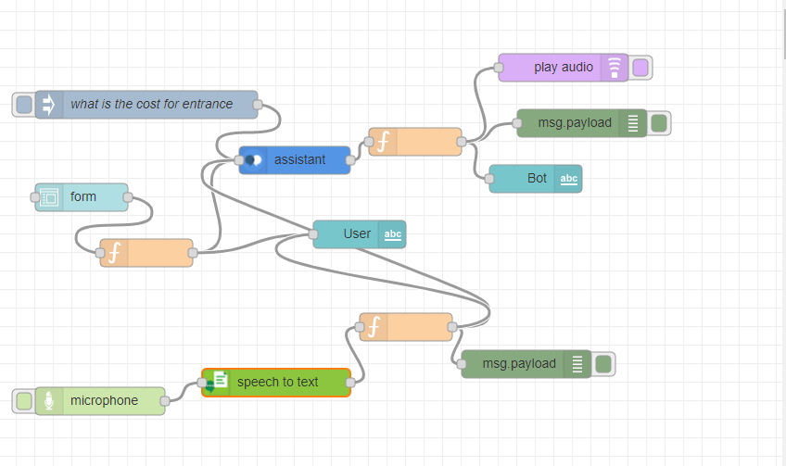

**CONCLUSION**

Smart Assistant will teach you how to create useful chatbots without the need to write any code. Leveraging IBM Watson's Natural Language Processing capabilities, you'll learn how to plan, implement, test, and deploy chatbots that delight your users, rather than frustrate them.

New jobs requiring this specific skill are being added every day, consultants demand premium rates, and the interest in chatbots is quickly exploding.

Future Scope

Voice search has been a hot topic of discussion. Visibility of voice will undoubtedly be a challenge. This is because the visual interface with voice assistants is missing. Users simply cannot see or touch a voice interface unless it is connected to the Alexa or Google Assistant app. Search behaviors, in turn, will see a big change. In fact, if tech research firm [Juniper Research is correct, voice-based ad revenue could reach $19 billion by 2022](https://techcrunch.com/2017/11/08/voice-enabled-smart-speakers-to-reach-55-of-u-s-households-by-2022-says-report/), thanks in large part to the growth of voice search apps on mobile devices.

**BIBILIOGRAPHY**

IBM became the first to introduce a voice assistant with its Shoebox device.

Software genre: Virtual assistant

Developer: Google